Evaluating a Hybrid Night Shuttle Policy for Columbia: A Simulation-Based Study
Chung-Yeh Yang, Lucas Zheng, Muya Guoji, Sabrina Wang, Sophia Tu

1. Background and Motivation
Columbia’s Night Shuttle serves students in the evening until 3 AM, using corner-to-corner service before 8pm and door-to-door service afterwards. Corners are attractive operationally because they allow drivers to serve passengers in batches along main avenues, while door-to-door service offers higher perceived safety and convenience but requires resource-intensive navigation of side streets
While students are offered greater convenience in terms of not having to walk with door-to-door service, they also face higher wait times compared to rides during the corner-to-corner time block, especially between 8-11pm, as shown in Figure 1:Average Wait Time of Completed Rides by Hour. Historical operations data from Via indicates a discrepancy in service metrics: the system routinely delivers average travel times under 10 minutes, yet average wait times often exceed 20 minutes during the night period. This gap suggests that the primary bottleneck is not vehicle speed, but rather the geometric inefficiency of how vehicles are routed and shared.
The goal of this study is to evaluate whether a rule-based Hybrid Policy offers a superior balance. Rather than treating the choice between corner and door service as a binary system-wide decision, the model evaluates a granular approach: routing riders to fixed points (select corners) only if they are within a short walking threshold, while preserving door-to-door access for riders farther from those points.
To quantify this, we developed a discrete-event simulation using real mid-September to October 2025 demand and October 2025 supply data. The simulation tests three distinct policies:
- Door-only: All riders receive door-to-door service.
- Corner-only: All riders are routed to the nearest fixed point, which are all located at an intersection of an avenue and street. In our simulation, “corners” are located every 3 streets.
- Hybrid: Riders are routed to fixed points located at select corners if and only if their walking time is within a 3-minute threshold for both origin and destination; otherwise, they receive door-to-door service. The fixed points located at certain corners are assigned every 3 streets between 103rd St and 135th St and along the following avenues, totaling 55 corners used in our simulation: Broadway, Amsterdam, Morningside Drive, and St. Nicholas Ave.

2. Data and Study Design
The simulation relies on two primary data sources: an operational supply plan and historical ride requests.
Supply Data: The model utilizes the October 2025 supply plan, which specifies the active number of Night Shuttle vehicles by date and hour (6 PM to 3 AM). If specific data is missing for a date-hour cell, a baseline of 16 vehicles is assumed.
Demand Data: The demand profile is derived from Via’s “Ride Requests” records from September 15 to October 31, 2025. The dataset was filtered to include only completed trips requested between 6 PM and 3 AM during October, yielding 18,286 rides.
- Average Historical Wait Time: ~24 minutes

3. Simulation Framework
The analysis used SimPy to model the interactions between fleet capacity, street geometry, and passenger demand.

3.1 Network and Friction Modeling
For simplification, we approximated the area as a grid by assigning each avenue a single longitude value and using an approximate latitude step to determine the latitude distance between streets. Using this grid system, we generated 55 fixed "corners" at the intersections of 11 streets (between 103rd to 135th) and 5 avenues. Crucially, the simulation models the physical difference between navigating avenues and side streets using specific friction factors:
- Corner-to-Corner Trips: The calculated Haversine distance is multiplied by 1.1. This assumes travel primarily occurs on straight avenues.
- Door-to-Door Trips: The distance is multiplied by 1.3. This 20% friction penalty explicitly models the time cost of turning into side streets, navigating one-way grids, and maneuvering around double-parked vehicles.
To test system resilience, the model injects stochastic "chaos" variables:
- Traffic Lights: Estimated every 250 meters.
- Delays: A probabilistic logic assigns a 45% chance of a 40-second delay at every intersection and a 10% chance of "heavy congestion" (doubling travel time) for any given trip.

3.2 Dispatch Logic and Cost Function
The vehicle dispatcher serves as the decision-making engine. When a request arrives, the dispatcher does not simply select the nearest vehicle. Instead, it employs a Multi-Objective Weighted Cost Function to evaluate every possible assignment. The vehicle with the lowest score receives the passenger.
The logic prioritizes system stability over individual speed, utilizing the following weights found in the algorithm:
- Queue Penalty (Weight: 5.0): The highest priority is placed on load balancing. The system prefers to assign a vehicle that is further away but empty, rather than one that is close but already has a queue.
- Wait Time (Weight: 4.0): Minimizing the immediate passenger wait is the secondary priority.
- Detour Penalty (Weight: 3.0): The system accepts minor detours for existing passengers to serve new requests, provided the first two priorities are met.

3.3 SLA "Look-Ahead" Enforcement
To reflect real-world constraints, the dispatcher enforces a strict Service Level Agreement (SLA). Before finalizing any assignment, the system simulates the route to its completion. If adding a passenger causes any rider on that vehicle to wait longer than 50 minutes, the assignment is rejected. If no existing vehicle can take the passenger without violating this SLA, a dedicated overflow vehicle is spawned.

3.4 Hybrid Scenario Logic
The Hybrid policy is governed by a strict geometric gate to ensure accessibility:
- The Threshold: A maximum walking time of 3.0 minutes.
- The Logic: A rider is assigned to Corner Service if and only if:
(Walk to Pickup < 3 min) AND (Walk from Drop-off < 3 min).
- The Default: If either end of the trip exceeds the threshold, the rider automatically defaults to Door-to-Door Service. This prevents the system from stranding students in less accessible locations.

4. Results

4.1 Overall Performance Comparison
Table 1 showcases the result after simulation. The Door Scenario yields the longest total trip times (38.5 min). The convenience of zero walking is offset by high system friction, resulting in longer queues. The Corner Scenario is the most time-efficient (31.0 min total) but imposes a blanket walking requirement. The Hybrid Scenario reduces total journey time by approximately 10% (2.9 minutes per rider) compared to the current system, striking a balance between efficiency and access.
Metric | Door-to-Door | Corner-to-Corner | Hybrid (Proposed)
Avg Wait Time | 19.2 min | 15.9 min | 17.8 min
Avg Ride Time | 19.3 min | 15.1 min | 17.8 min
Avg Walk Time | 0.0 min | 4.6 min | 1.9 min
Avg Total Journey | 38.5 min | 31.0 min | 35.6 min

Table 1: Results of three types of simulation

The visualization of the results in Table 1 are shown in Figure 2: Average Travel Time Breakdown by Scenario. Our hybrid model strikes a compromise between the door-to-door model only and corner-to-corner only models by reducing the average waiting time in comparison to the door-to-door only model and also reducing the average walking time in comparison to the corner-to-corner only model, where the corners are our determined fixed points. Moreover, as shown in Figure 3: Average Travel Time by Scenario, the hybrid model not only offers an improvement in average waiting time in comparison to the door-to-door only model, but it also offers a reduction in average ride time as well, yielding a lower average total journey time as mentioned above. The hybrid model, which draws upon the operational efficiencies of the corner-to-corner only model, produces an improvement in average waiting and ride times while also providing additional convenience through offering door-to-door for certain scenarios and reducing average walk time.

4.2 Hybrid User Segmentation
The Hybrid policy effectively segments the population based on local geometry. With a 3-minute threshold
- Corner Users (~57%): These riders, requesting near avenues, are routed to one of our fixed points at select corners. They incur an average 1.8-minute walk but benefit from significantly faster pickups and drop-offs.
- Door Users (~43%): These riders remain on door-to-door service. Notably, their average wait time also improves slightly (17.74 min) compared to the pure Door scenario (17.86 min). By moving 57% of volume to efficient arterial routes, the system clears queues faster, indirectly benefiting those who require door service.
From Figure 4: Average Travel Time Breakdown by Scenario we can see that riders routed to corners see substantially shorter ride and wait times, resulting in a total trip time nearly six minutes faster than door-to-door riders, even after accounting for a small walking component. Also, the door group would still benefit from reduced system congestion, as shifting a part of the rider to corner group frees up capacity for those who require door service. Overall, Figure 4 highlights how the Hybrid policy improves systemwide performance while preserving equitable access.

4.3 Temporal and Weekly Patterns
Time of Day: The number of drivers change by hour based on the supply plan data, and we only consider select corners. In our simulation, the policy impact is highest during the evening peak between 6 to 8 PM (Figure 5: Average Travel Time Hourly Trend by Scenario). Under the Door policy, the average wait times in this window approach 30 minutes. The Hybrid policy aims to mitigate this peak by grouping passengers on avenues. Post-1 AM, the absolute difference between policies narrows as demand thins, though the efficiency ranking remains consistent.
Moreover, we see a constant, visible discrepancy between the average travel time before 8pm and after 8pm (Figure 6: Average Travel Time Before 8pm v.s. After 8pm). But out of the three service types, the hybrid service is the one that gets noticeably faster after 8pm.
Weekday vs. Weekend: Analysis indicates minimal variance between weekday and weekend patterns. As Figure 7: Average Travel Time Weekday v.s. Weekend shows, the weekends show slightly lower absolute wait times due to reduced traffic friction, the relative performance advantage of the Hybrid model over the Door model remains constant.

4.4 Sensitivity to Grid Density
We tested a variation of the network by increasing corner density (placing fixed points every 2 streets instead of 3, increasing corners from 55 to 85). The results showed negligible change in wait or ride times (< 0.2 minutes difference). This indicates that the current grid density is sufficient; the efficiency gains come from the macro policy shift (moving cars out of side streets) rather than the micro-optimization of stop locations.
current corner -> 55 (Every 3 street)
new_corner -> 85 (Every 2 street)
Metric | Current(Avg) | New(Avg)
Wait Time(Door) | 19.2 min | 19.4 min
Wait Time(Corner) | 15.9 min | 16.0 min
Wait Time(Hybrid) | 17.8 min | 18.0 min
Ride Time(Door) | 19.3 min | 19.7 min
Ride Time(Corner) | 15.1 min | 15.3 min
Ride Time(Hybrid) | 17.8 min | 17.9 min

Table 2: Comparison of Travel Time by Different Number of Corner (Hybrid Mode)

 | Current | New
Door Users | 42.6% | 41.6%
Corner Users | 57.4% | 58.4%

Table 3: Comparison of User Percentage by Different Number of Corner (Hybrid Mode)

Policy Implications
The simulation results support three primary conclusions regarding the Night Shuttle operation:
- Efficiency is Geometric: The inefficiency of the Door-to-Door model is structural. Treating arterial avenues (low friction) and side streets (high friction) identically allows low-cost requests to consume high-cost resources. The Hybrid model functions as a geometric filter, processing ~58% of demand via lower-friction routes.
- Equity is Preserved: The Hybrid model is not a binary switch. By utilizing the "3-minute AND" logic, the system protects the 42% of students in less accessible areas. These students are not penalized; rather, they benefit from a fleet that is less bogged down by easily avoidable detours.
- Operational Externalities: While this study focuses on time, the reduction in side-street navigation implies a reduction in Vehicle Miles Traveled (VMT). This correlates with reduced fuel consumption, lower emissions, and less noise disturbance on residential blocks.

Limitations and Future Work
- Data Scope: The model relies on October 2025 data. While representative, it does not account for extreme outliers such as finals week demand surges or severe weather events that might reduce walking speeds. Start times for service and demand vary by month.
- Behavioral Assumptions: The simulation assumes compliance—that riders assigned to corners will accept the assignment. Real-world implementation would need to account for opt-in rates if we allow users to choose or non-compliance if keeping it rule-based.
- Cost Analysis: This study uses time as the primary currency. Future iterations could translate driver-hours saved into financial metrics to determine the potential return on investment for the operational changes required.
- Fixed Points Locations: Further analysis allowing for variation in intervals (e.g. streets used: 103, (+3) 106,(+4) 110, (+3) 113...) to determine the best combination of corner locations and respective walking threshold to use for a point could be conducted.

7. Conclusion
This study utilized a detailed, data-driven simulation to evaluate service policies for Columbia’s Night Shuttle. By feeding real October 2025 demand into our model, we quantified the trade-offs between convenience and efficiency.
The results demonstrate that a Hybrid Policy is a good path forward for rides after 8PM. It captures the majority of the efficiency gains of a Corner-only system, reducing total journey times by roughly 10% without abandoning the safety and accessibility of Door-to-Door service for the substantial minority of riders who rely on it.
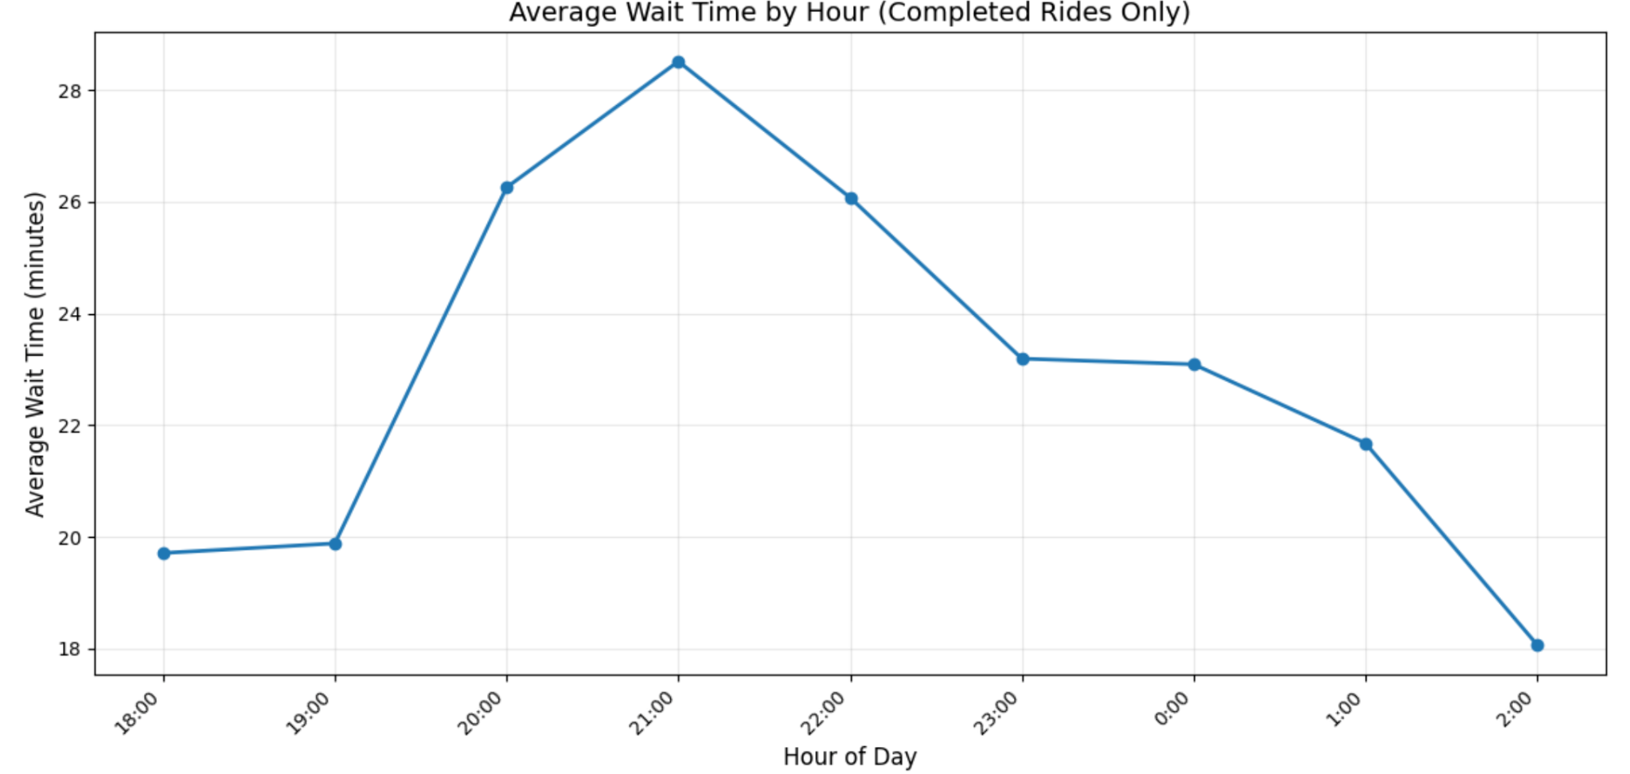
Appendix

Figure 1: Average Wait Time of Completed Rides by Hour
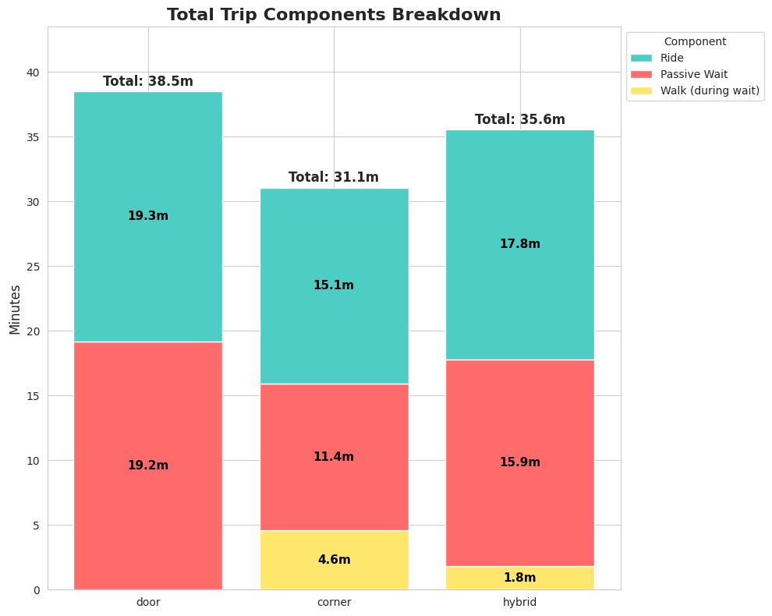
Figure 2: Average Travel Time Breakdown by Scenario
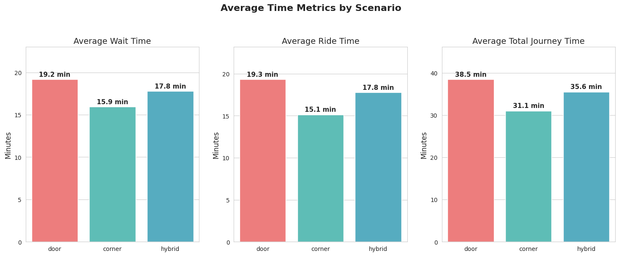
Figure 3: Average Travel Time by Scenario
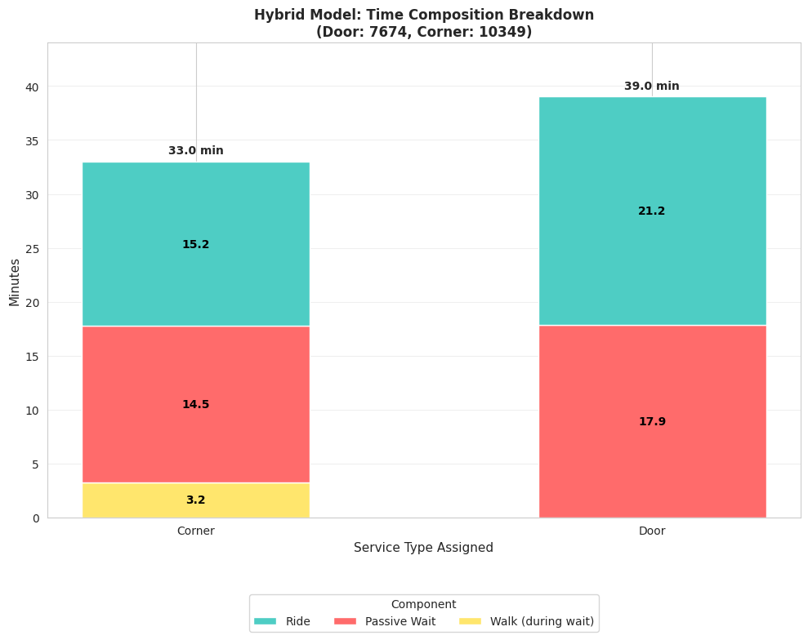
Figure 4: Average Travel Time Breakdown by Scenario in Hybrid System

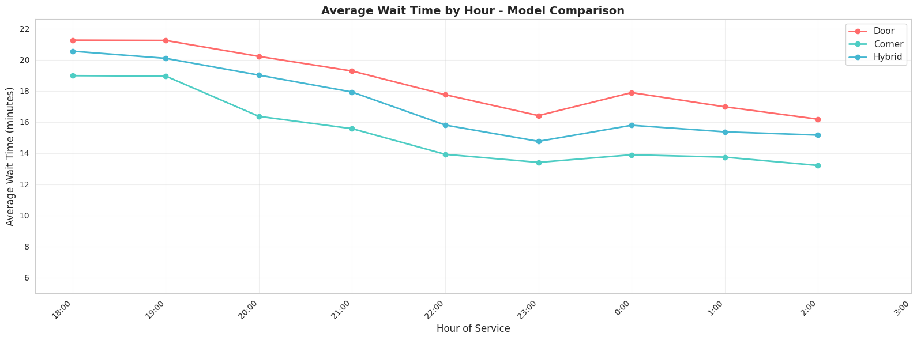
Figure 5: Average Travel Time Hourly Trend by Scenario
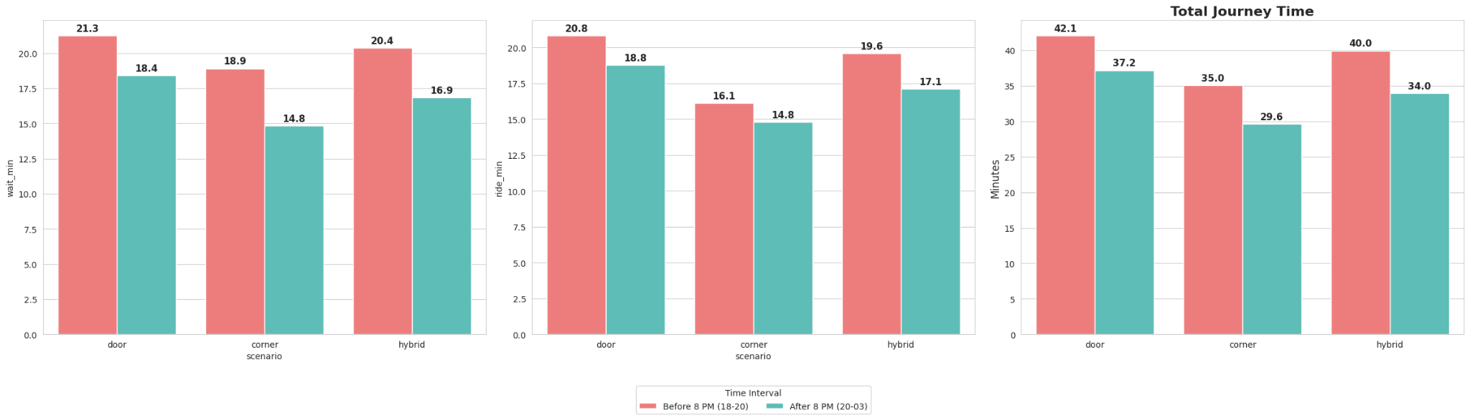
Figure 6: Average Travel Time Before 8pm v.s. After 8pm

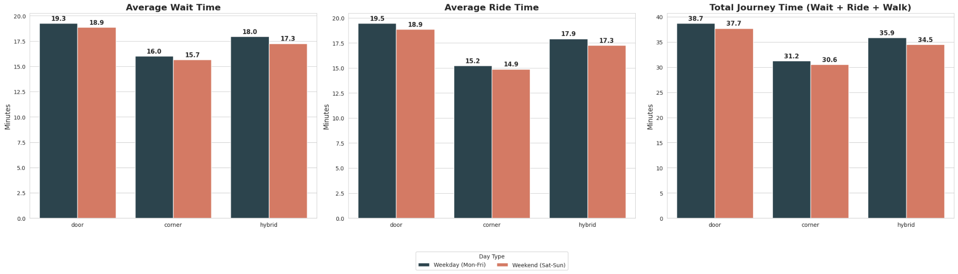
Figure 7: Average Travel Time Weekday v.s. Weekend

Datasets Used in Analysis:
- Ride Requests_2025-11-11-part-2.csv: https://courseworks2.columbia.edu/courses/229044/files?preview=25698513
- CUL October 2025 Supply Plan.xlsx: https://courseworks2.columbia.edu/courses/229044/files?preview=25698511

